**Name:** Rameen **Roll No:** 2023-EE-03

EE-322L Analog and Digital Communication Marks Obtained: ________

**Lab Report**

**Experiment No. 1**

**Exponential Fourier Series**

**Note:**

* **Don’t forget to include the rubrics table (available at the end in this document), otherwise reports will not be graded.**
* **Copy-pasted and plagiarized reports will get zero marks**

**Ensure proper comments are there in the source code of each task**

**Note:**

* **Don’t forget to include the rubrics tables (available at the end in this document), otherwise reports will not be graded.**
* **Copy-pasted and plagiarized reports will get zero marks**
* **Ensure proper comments are there in the source code of each task**

1. **Objective**

To verify that the Discrete Fourier Transform (DFT) corresponds to a sampled version of the Discrete-Time Fourier Transform (DTFT) in the frequency domain using a finite discrete rectangular pulse.

1. **Technical Background**

The DTFT represents the frequency spectrum of a discrete-time signal over a continuous frequency range, while the DFT provides frequency samples at discrete points. When the number of DFT points NNN is sufficiently large, the DFT samples approximate the DTFT. This relationship is fundamental in digital signal processing where finite-length signals are analyzed in the frequency domain.

1. **Task-1**
   1. ***Description of Task-1***

Consider the following rectangular pulse in MATLAB

**𝑢[𝑛] = [1,1,1,1,1]** where 𝑛 = [0,1,2,3,4]

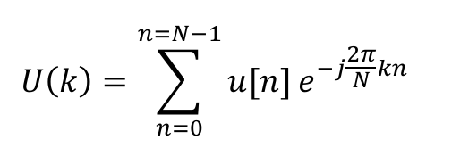 Find its Discrete Fourier Transform (DFT) by

Here 𝑁 is any length greater than or equal to 𝑁 = 5. Choose 𝑁 = 5 and plot phase and amplitude of 𝑈(𝑘) with respect to 𝜔𝑘 , where 𝑘 goes from 0 𝑡𝑜 4.

* 1. ***Source Code for Task-1***

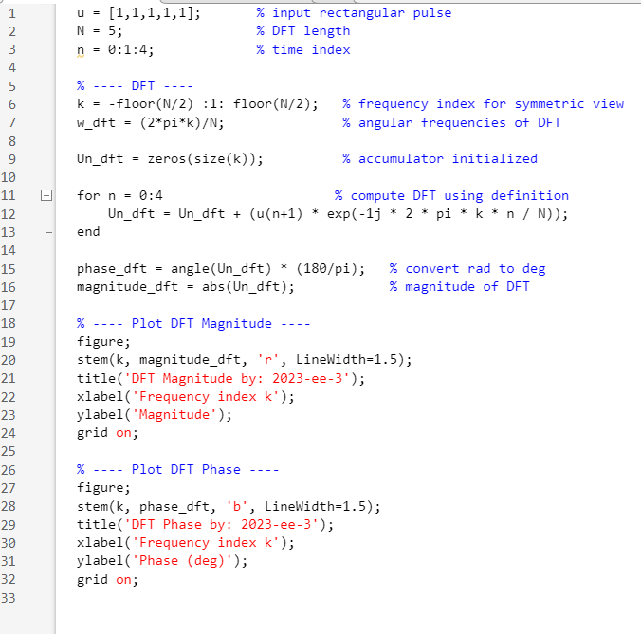

* 1. ***Results and Discussions for Task-1***

This plot shows the magnitude and phase of DFT respectively for N=5

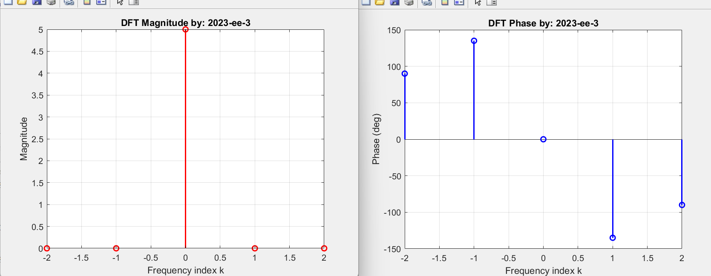

The sampling frequency is low, due to which the DFT obtained does not give a lot of information about the frequency spectrum of the signal.

1. **Task-2**
   1. ***Description of Task-2***

Plot the DTFT of the same signal and compare it with the DFT.

* 1. ***Source Code for Task-2***

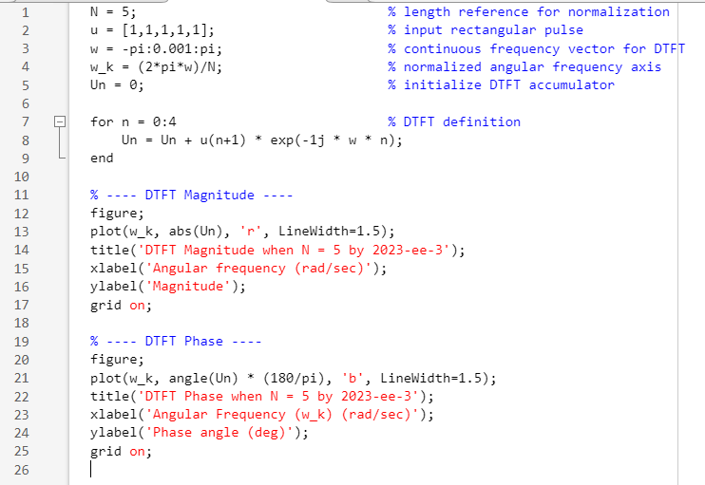

* 1. ***Results and Discussions for Task-2***

This plot shows the magnitude and phase of DTFT respectively.

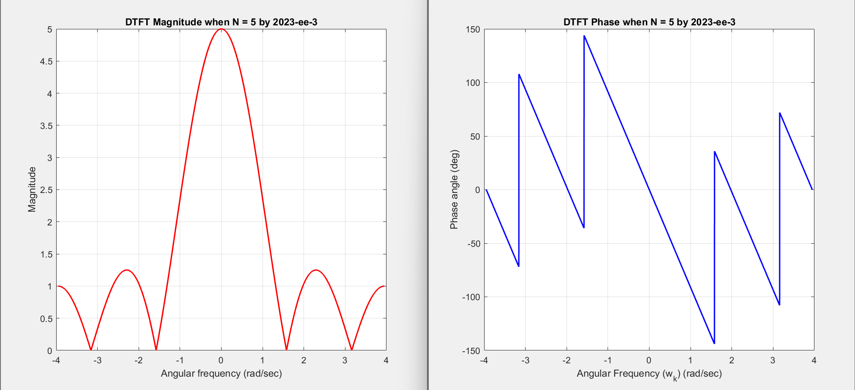

Comparing the DFT with the DTFT shows that the amplitude and phase values at the DFT’s sampled frequency points coincide with the corresponding values of the DTFT. However, the DFT appears as a low-resolution, discretely sampled representation of the continuous DTFT spectrum.

1. **Task-3**
   1. ***Description of Task-3***

Now set the number of discrete samples N to your roll number which is 111, and then compare the resulting DFT with the previous DFT and DTFT.

* 1. 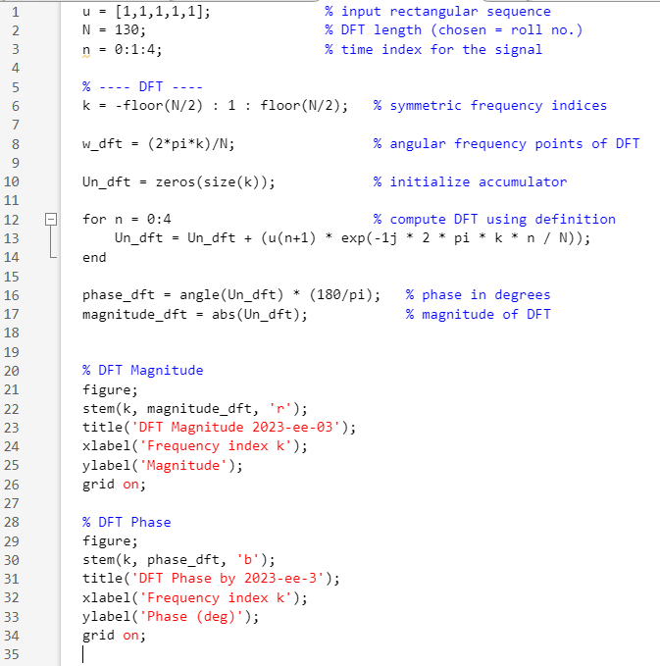***Source Code for Task-3***
  2. ***Results and Discussions for Task-3***

This plot shows the magnitude and phase of DFT respectively for N= 130

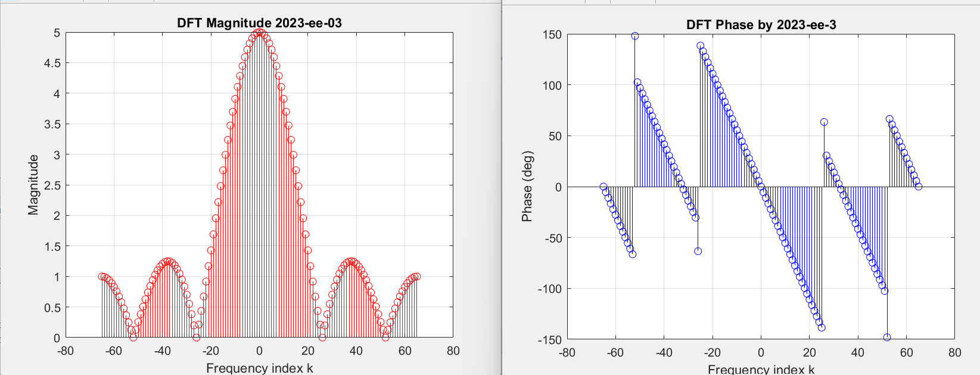

This DFT shows a closer resemblance to the DTFT compared to the result in Task-1. The improvement comes from using a larger number of frequency samples, which effectively increases the sampling resolution in the frequency domain. As a result, the DFT captures more detail of the spectrum and represents the DTFT more accurately than before.

1. **Conclusion**

The results confirm that the DFT is a sampled form of the DTFT. When the length NNN is small, the frequency resolution is poor and the DFT does not represent the spectral content accurately. Increasing NNN improves resolution but also increases computational cost. Therefore, an appropriate choice of NNN is essential when analyzing signals in the frequency domain using the DFT.  
With the availability of efficient algorithms like the Fast Fourier Transform (FFT) and advancements in hardware, the computational burden has become less significant in practical applications.

**Rubrics for Experiment No.**

|  |  |  |  |  |
| --- | --- | --- | --- | --- |
| **Performance** | **Exceeds expectation (2)** | **Meets expectation (1)** | **Does not meet expectation (0.5)** | **Marks** |
| **R1:** Knowledge of required functions for code design.  **Marks: 0-2** | Has required knowledge for code | Has partial knowledge for code | Has no knowledge for code |  |
| **R2:** Simulation of experiment **Marks: 0-2** | Simulates all the tasks correctly by himself | Needs guidance to simulate the tasks correctly | Incapable to simulate the tasks correctly by himself even with  guidance |  |
| **R3:** Demonstrate proper results with justification  **Marks: 0-2** | Correct results are provided with required  justification | Results are provided with minor errors and/or with little  justification | Results are provided with major errors and/or with no  justification |  |

**Rubrics for Lab Manual No.**

|  |  |  |  |  |
| --- | --- | --- | --- | --- |
| **Performance** | **Exceeds expectation (0.5)/(0.25)** | **Meets expectation (-)/(-)** | **Does not meet expectation**  **(0)/(0)** | **Marks** |
| **R1:** Timely submission  **Marks: 0-0.5** | The submission is on  time | --- | Late submission |  |
| **R2:** Report completeness  **Marks: 0-0.25** | All relevant calculations,  specifications, code, graphs, and results are provided with proper explanation. | All the relevant calculations,  specifications, code, graphs and results  are provided but with little  explanation and justification. | Most of the relevant graphs, results, calculations,  specifications, and code are missing, as well as  their proper explanation and justification is also missing. |  |
| **R3:** Error-free writeup  **Marks: 0-0.25** | The submitted assignment is without any  plagiarism and formatting errors. | Some parts of the submitted  assignment contain formatting errors and plagiarized material. | The submitted  assignment is mostly plagiarized and contain formatting errors. |  |